AROOBA SHEHZADI

LAB 6 TASKS
231678_AROOBA

TASK 1
@page "/OneWayBinding"
@rendermode InteractiveServer

<h3>One Way and Two Way Binding</h3>

<p>One Way Binding:</p>
<p>@message</p>

<p>Two Way Binding:</p>
<input @bind="message" />

@code {
private string message = "Hello Blazor";
}

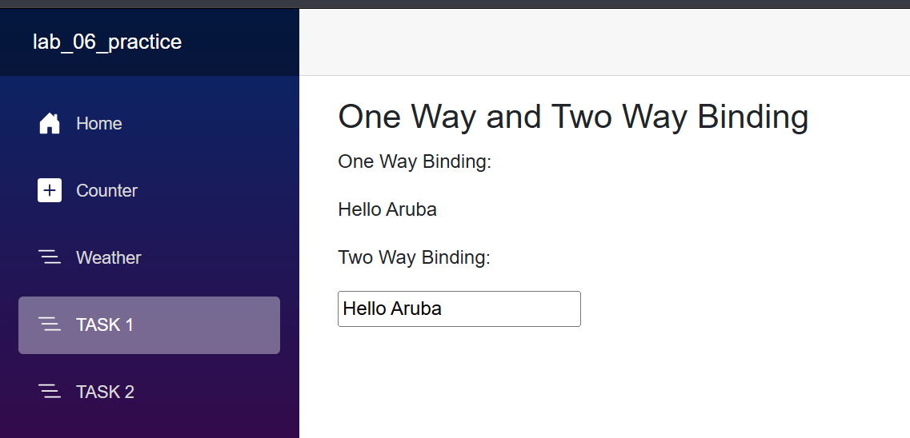

TASK 2
@page "/counter"
@rendermode InteractiveServer

<PageTitle>Counter</PageTitle>

<h1>Counter</h1>

<p role="status">Current count: @currentCount</p>

<button class="btn btn-primary" @onclick="IncrementCount">Click me</button>

@code {
private int currentCount = 0;

private void IncrementCount()
{
currentCount++;
}
}

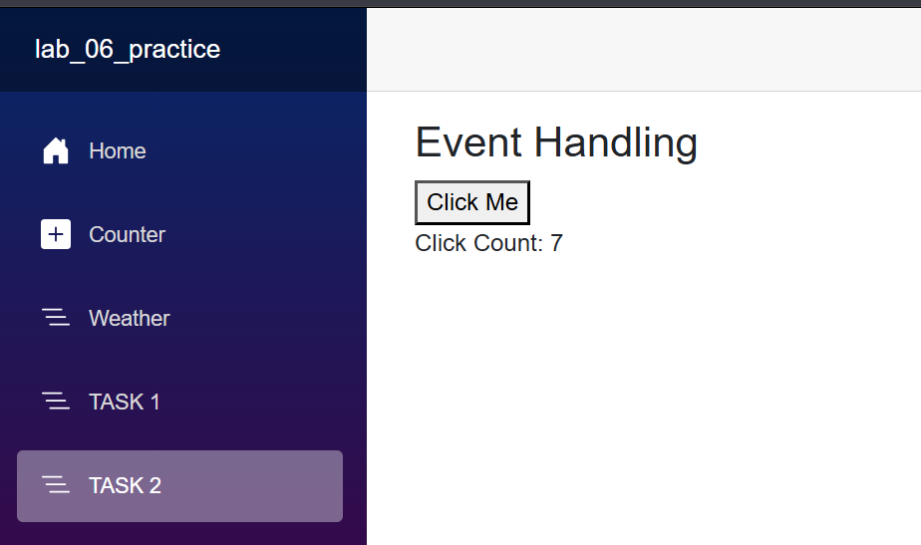

TASK 3
@page "/DynamicUI"
@rendermode InteractiveServer
<h3>DynamicUI</h3>

<input @bind="newItem" placeholder="Enter Item"/>
<button @onclick="AddItem">ADD</button>

<ul>
@foreach (var item in items)
{
<li>@item</li>
}

</ul>
@code {
private string newItem = "";
private List<string> items = new List<string>();

private void AddItem()
{
if(!string.IsNullOrEmpty(newItem))
{
items.Add(newItem);
newItem = "";
}
}
}
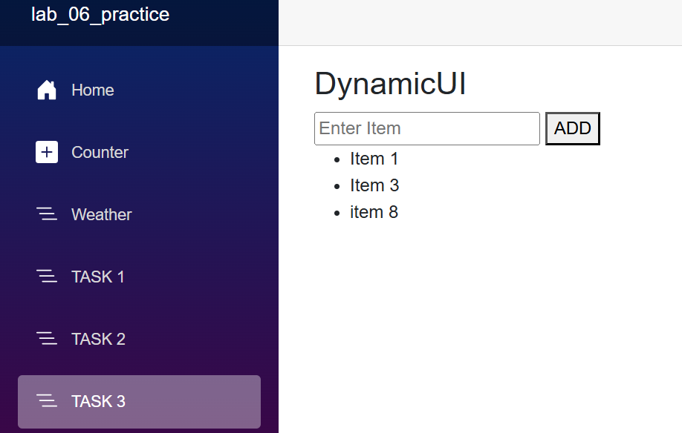

LAB TASK 1
@page "/UserForm"
@rendermode InteractiveServer

<h3>User Form</h3>

<div>
<label>Name:</label>
<input @bind="nameInput" placeholder="Enter your name" />

<label>Age:</label>
<input @bind="ageInput" type="number" placeholder="Enter your age" />

<label>Email:</label>
<input @bind="emailInput" type="email" placeholder="Enter your email" />
</div>

<p>
<button @onclick="DisplayData">Submit</button>
</p>

@if (isDataSubmitted)
{
<h4>Entered Details:</h4>
<p><strong>Name:</strong> @name</p>
<p><strong>Age:</strong> @age</p>
<p><strong>Email:</strong> @email</p>
}

@code {
private string nameInput { get; set; } = "";
private int ageInput { get; set; }
private string emailInput { get; set; } = "";

private string name { get; set; } = "";
private int age { get; set; }
private string email { get; set; } = "";

private bool isDataSubmitted = false;

private void DisplayData()
{
name = nameInput;
age = ageInput;
email = emailInput;
isDataSubmitted = true;
}
}

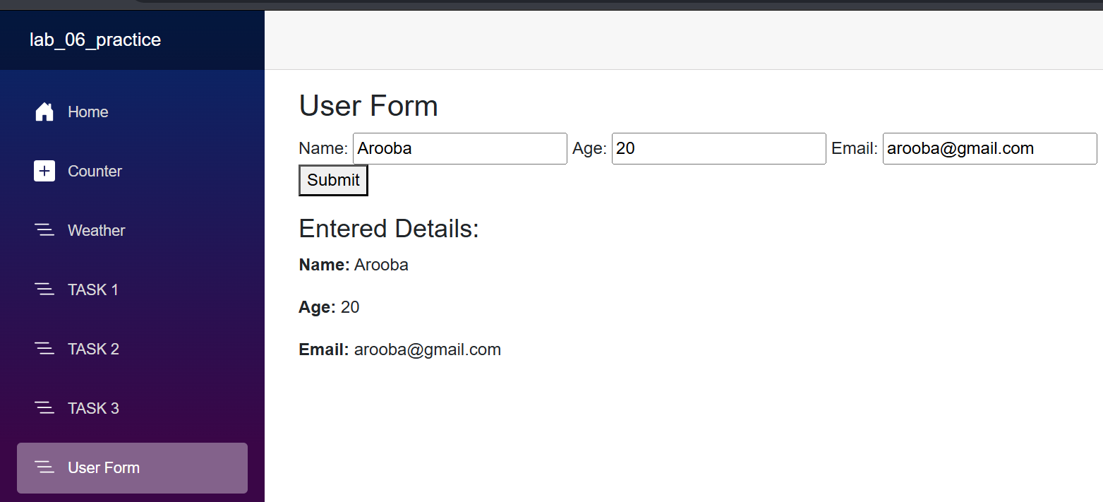

LAB TASK 2
@page "/CounterComponent"
@rendermode InteractiveServer
@code {
private int count = 0;
private bool isMessageVisible = false;

private void IncrementCount()
{
count++;
}

private void ToggleMessage()
{
isMessageVisible = !isMessageVisible;
}
}

<div>
<h3>Counter Component</h3>

<p>Current Count: <strong>@count</strong></p>

<button @onclick="IncrementCount">Increase Count</button>
<button @onclick="ToggleMessage">Toggle Message</button>

@if (isMessageVisible)
{
<p>The message is now visible!</p>
}
</div>

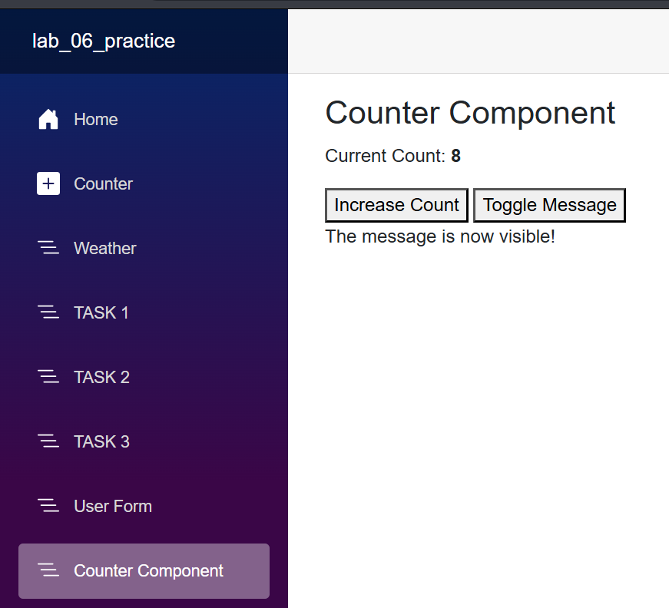

LAB TASK 3
@page "/TaskList"
@rendermode InteractiveServer
@code {
private List<string> tasks = new();
private string newTask = string.Empty;

private void AddTask()
{
if (!string.IsNullOrWhiteSpace(newTask))
{
tasks.Add(newTask);
newTask = string.Empty;
}
}

private void RemoveTask(string task)
{
tasks.Remove(task);
}
}

<div>
<h3>Task List</h3>

<input @bind="newTask" placeholder="Enter a task" />
<button @onclick="AddTask">Add Task</button>

@if (tasks.Count > 0)
{
<ul>
@foreach (var task in tasks)
{
<li>
@task
<button @onclick="() => RemoveTask(task)">Remove</button>
</li>
}
</ul>
}
else
{
<p>No tasks added yet.</p>
}
</div>

